Data types specify different sizes and values that can be stored in a variable.

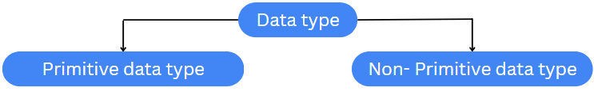

The primitive data types include boolean, char, byte, short, int, long, float, and double.

The non-primitive data types include Classes, Interfaces, and Arrays.

The standard data types are:

* Integer(int) - 4 byte
* Floating numbers(float) - 4 byte
* Character(char) - 1 byte
* Boolean(boolean) - 1 byte
* Double(double) - 8 byte
* Short(short) - 2 byte
* Long(long) - 8 byte

Example:

